Name:Piyush Vishnoi

Sap:500067083

Roll no:71

Lab:11

Lab experiment - 11

Vagrant and virtual box setup

**Step-1:** Download and Install Virtual Box(5.2.44) as well as Vagrant(2.2.10)

* **Virtual box** [**https://www.virtualbox.org/wiki/Download_Old_Builds_5_2**](https://www.virtualbox.org/wiki/Download_Old_Builds_5_2)
* **Vagrant**

[**https://www.vagrantup.com/**](https://www.vagrantup.com/)

**Step-2: After installing vagrant check the version and make a folder to initialize vagrantfile.**

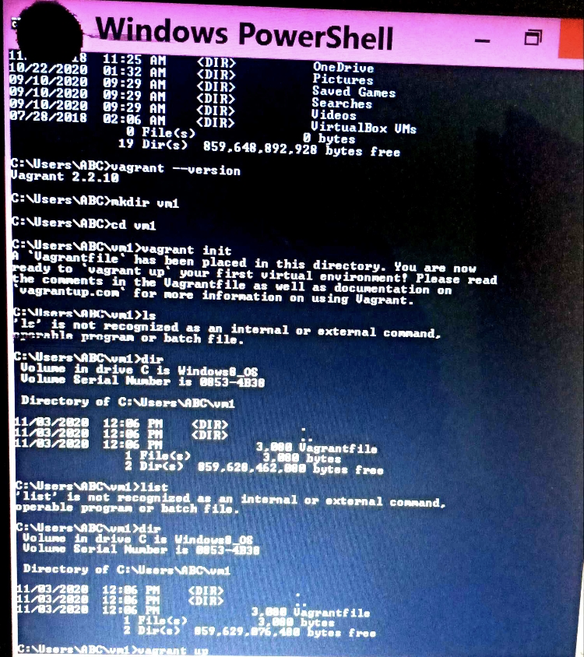

**Step-3: Add config.vm.box = "ubuntu/xenial64" to vagrantfile** 

**Step-4: Run vagrant up command**

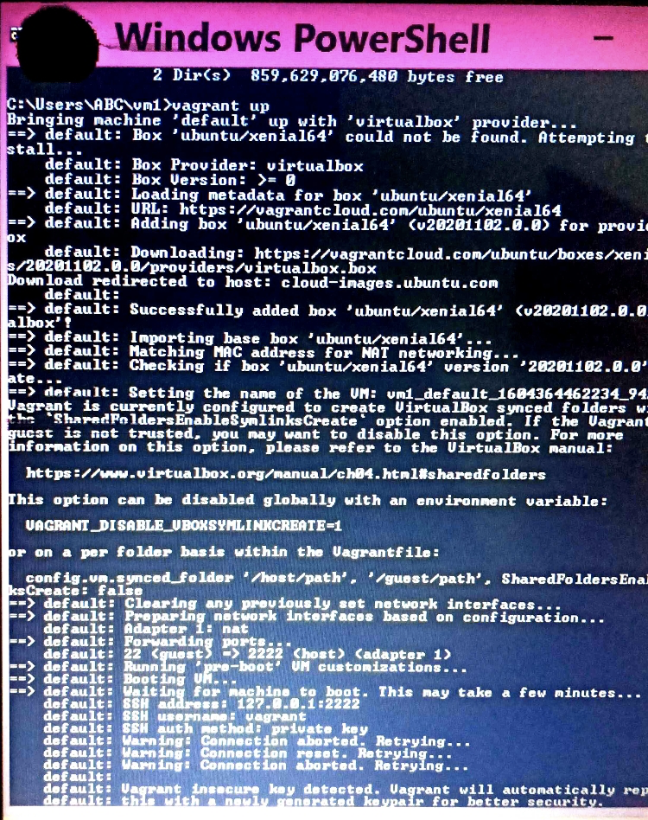

**Step-5: Run vagrant ssh command to enter the virtual machine.**

